Request Lifecycle

If you go to www.google.com (not using any forms, just wanting the site), this is what happens:

1. First the browser needs to translate www.google.com to an IP address if it does not already know it. If it knows it, nothing happens at this point. If it does not know it, it contacts a DNS server to resolve the name.
2. Then browser will open a TCP connection to the IP address of www.google.com and send a HTTP GET request over. In this example it will be  
   GET / HTTP/1.1  
   Host: www.google.com
3. The server software will get this HTTP request. It will somehow generate a HTTP response and send that back trough the TCP connection. How the server does this is server software dependent. You can for example plug in application code in Apache, or just make Apache return a file from the file system. PHP is an application called by some software, which then generates the response sent to the browser. When the response is sent, in HTTP version 1.0 the connection is closed. HTTP 1.1 can have persistent connections though.
4. When the browser gets the response, it typically renders it on screen. The HTTP request is now done. A click on "search" will send a new request to the server.

GET, PUT, POST, DELETE and others are [HTTP request methods](http://tools.ietf.org/html/rfc2616#section-5.1.1). They have special meaning which you can see in the RFC.

[Cookies](http://tools.ietf.org/html/rfc2109) are commonly used to identify the same user across multiple HTTP requests, called sessions. Therefore these cookies are called session cookies

You can debug the communication by using a network sniffer tool, for example [Wireshark](http://www.wireshark.org/). Firefox has a third party plug-in called [Tamper Data](https://addons.mozilla.org/en-US/firefox/addon/tamper-data/) that can change the request before they are sent to the server.

The [HTTP RFC](http://tools.ietf.org/html/rfc2616) is a good source of how it all works.

What is LARAVEL Request Lifecycle

<https://laravel.com/docs/5.8/lifecycle>

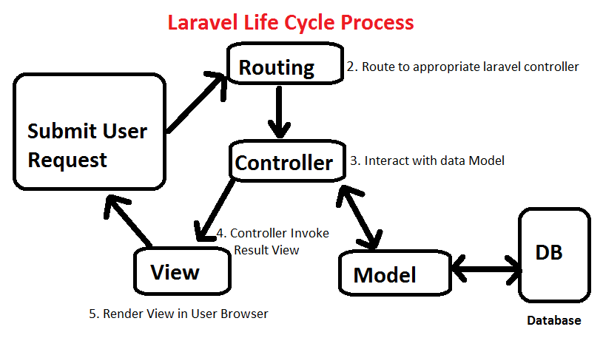

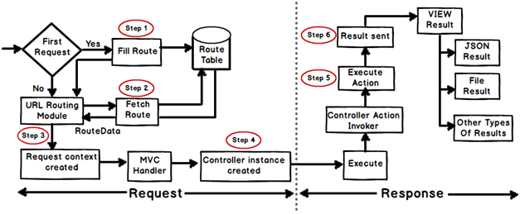

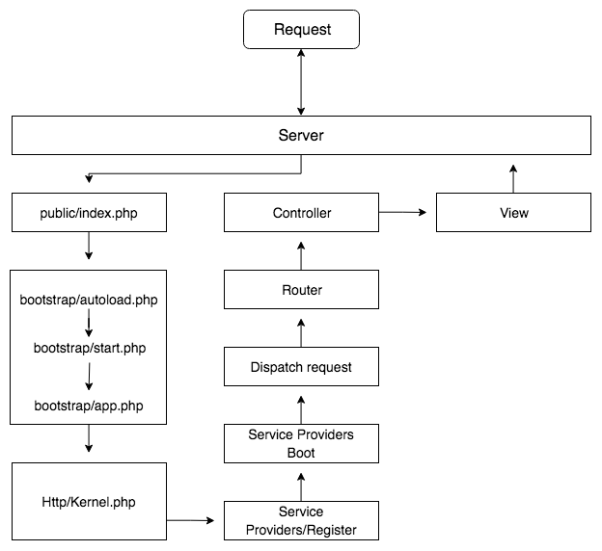

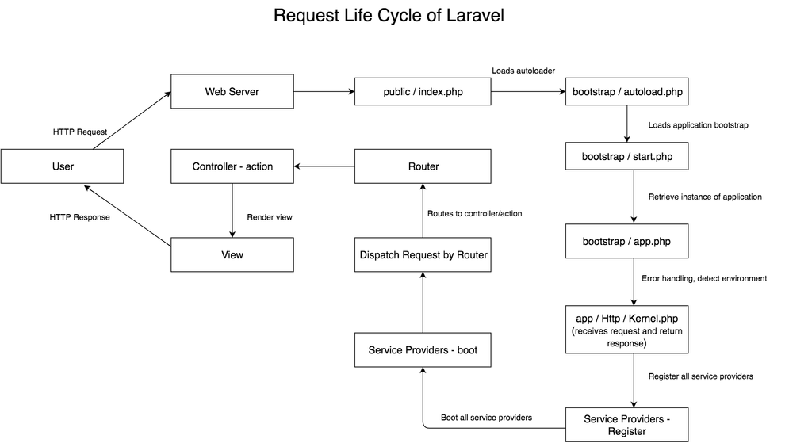

Creating Service Container

[https://symfonycasts.com/screencast/oo-ep2/service-container#](https://symfonycasts.com/screencast/oo-ep2/service-container)